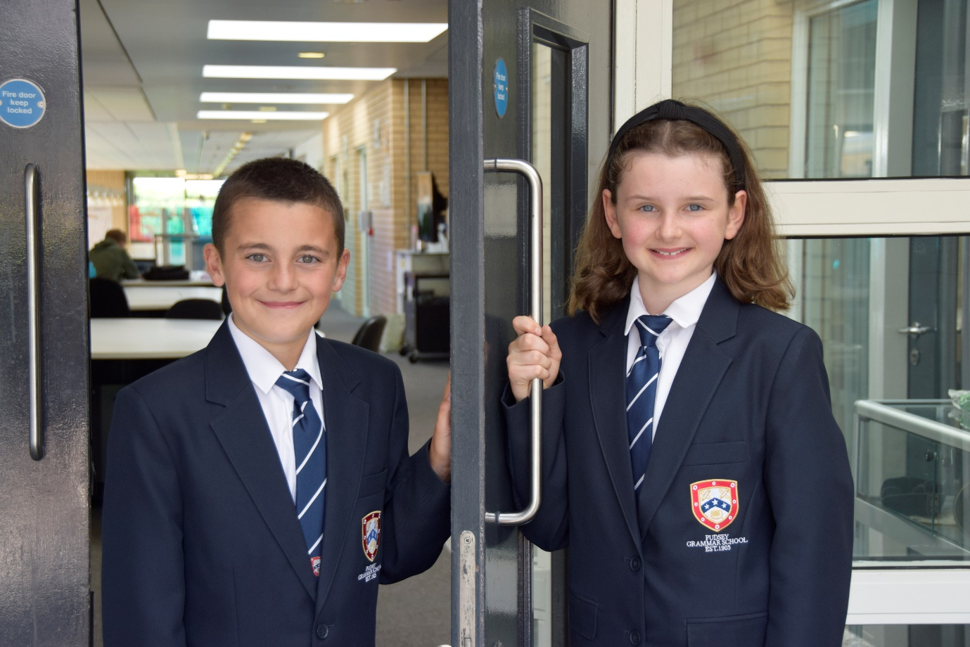

TEACHER OF
ENGLISH

APPLICATION PACK

Science Technician
Temporary Maternity cover

B3 7-11 £24,294 - £25,979 pro rata
Actual salary £20,895 - £22,645
37 hours per week term time only plus 5 days
Monday to Thursdays 8.00am - 4.00pm
Fridays 8.00am – 3.30pm

To start as soon as possible

Contents

- Introduction from the Headteacher
- Information on the post
- Job description
- Person specification
- Enhanced disclosure
- School Location and Travel Information

Introduction from the Headteacher

Thank you for the interest you have shown in the post of Science Technician at our school. This is an excellent opportunity to join our dynamic Science team.

Pudsey Grammar School is a heavily oversubscribed mixed comprehensive secondary school located in the heart of the market town of Pudsey. Situated between Leeds and Bradford, the town has always valued its independence from its two larger neighbours. The school has a long and proud history stretching back to 1905. The school has 1350 students with a thriving and expanding Sixth Form of over 250 students, all taught in a state of the art building. The innovative and unique style of the building creates a calm atmosphere very different to many secondary schools.

I was appointed in 2014 and since then we have received a letter from Amanda Spielman (HMCI Ofsted) which stated we ‘have transformed all aspects of the school.’ This assertion was further underlined in 2018 when the increase in our exam results resulted in the school being the most improved school in Leeds and one of the most improved in the country (we were delighted to follow these achievements up with our best ever GCSE exam results in 2019 which were above the national average). The pattern of improvement continued in 2020 with our Year 11 students achieving grades which were outstanding. The school had a highly successful Ofsted inspection in April 2019 and was judged as good in all areas, including our Sixth Form.

In 2022, the school was selected to be a national Behaviour Hub school. This is a Department for Education programme led by the Governments’ School Behaviour Advisor, Tom Bennett, which identifies schools who have ‘an exemplary behaviour culture’. We are one of only 20 secondary schools out of 4000 who have achieved this prestigious accolade and we are working with other schools across the north of England to improve their behaviour cultures.
In 2023, the school was awarded £4million by the Department for Education to build a new Sixth Form to support the growth in student numbers across Leeds. This exciting new development is scheduled to open in early 2025.
We have a comprehensive House system which runs across all year groups with over 30 diverse competitions across the year for students and one each half term for staff too. House assemblies take place once every three weeks lead by our eight House Leaders. At the end of each academic year, the winning House is awarded our 80-year-old Victor Ludorum Cup.
We are aiming to be a centre of excellence and every indicator we have, we are on track to achieve this goal. Continuing to recruit high calibre staff is a key priority of our strategy.

The following passages are taken from the 2019 Ofsted report:

‘The Principal leads the school with passion and determination.’

‘Behaviour, both in lessons, and about the school, is good. Pupils treat each other and adults with respect.’

‘There is a calm and purposeful atmosphere.’

‘Strong leadership, at all levels, is at the heart of this school’s success. The Principal is very ably supported by an effective team of senior leaders. The Principal describes the middle leaders as the ‘engine room of the school’ and they are indeed a real strength.’

‘Staff morale is high. Staff, at all levels, have embraced the changes and are proud to be part of a successful school.’

The school has a long tradition in the town, being established as Pudsey Grammar School in 1905. Although the school is taught in a state of the art building, our core values of respect, resilience, integrity, compassion and ambition are highly traditional and are based on the goal of ensuring that every student reaches their true potential.

Our school is not just about the students gaining knowledge and qualifications, although these are extremely important. We believe in teaching young people core values of decency, social skills and how to be a good citizen in an ever changing world. We want their character to develop and grow, and for them to leave us with an inquiring and independent mind. We want our students to gain the best qualifications they are capable of whilst experiencing a range of opportunities which are second to none. As a result, the school is extremely popular with our community and is significantly over-subscribed every year.

Our Sixth Form, which is rated as good by Ofsted, has grown rapidly in recent years following significant investment and we now have over 250 Post-16 students studying at Pudsey Grammar. We have a strong tradition of ensuring students access the best universities, including Oxford and Cambridge.

Our staff show exceptional dedication and commitment to our students. Relationships in the school are extremely strong and this underpins the ethos of the school. We pride ourselves in the care and support that we give our staff and, as a result, there is a real team spirit in the school where people enjoy being part of our school community. Teaching and learning is the key focus of the organisation and everything that we do is designed to ensure that the classroom experience for
the students is excellent. We are currently redesigning our curriculum to ensure that the education we offer is second to none.

We offer fantastic support and professional development to staff, which ensures that they are equipped with all the necessary skills to deliver excellent lessons to the students on a daily basis.

The school is a Foundation Trust school and our partners include global companies such as ASDA and HSBC bank, alongside leading local business and training provider, Appris. These high quality links allow our school to offer excellent careers
opportunities to students across the ability range. As a result, the school has 0% NEETs at Year 11.

We are currently part of the Red Kite Teaching Alliance, which is providing outstanding opportunities and CPD for all of our staff. Subject Leaders attend their Collaborative Learning Groups, which allows them to network and share best practice. This is further disseminated through the school via regular Department meetings and weekly Teaching & Learning briefings.

This clearly is an exciting time to join our school.

If you have a desire to be part of one of the most exciting and rewarding schools to work in, which will also provide you with excellent development opportunities, please complete the application form. Any further details can be obtained directly from the school’s HR Team: recruitment@pudseygrammar.co.uk) or our website www.pudseygrammar.co.uk

Mark McKelvie
Headteacher
Pudsey Grammar School

Details of advert

Job Title: Science Technician (Temporary Maternity cover)
Hours and working pattern: 37 hpw, Monday-Thursday 8.00 – 4.00, Friday 8.00-3.30
Grade: B3
Salary: £24,294 - £25,979 FTE (£20,895 -£ 22,645 Actual)
Start date: As soon as possible

We are looking to appoint an exceptional individual to join our Science Department. The role will include supporting teaching staff to ensure they can deliver inspirational and innovative teaching on a daily basis. The role will work collaboratively with the Senior Science Technician and Science Teaching staff to enable staff to deliver outstanding teaching and learning across the department.

The Science Technician will be highly efficient and have exceptional organisational skills, the ability to prioritise between competing workloads with a consistently professional approach to all aspects of the role and the drive and focus for continuous improvement.
Applicants will need to demonstrate that they can undertake a range of tasks as directed by the Senior Science Technician and Subject Leader of Science. Including:
- Distributing materials and audio visual equipment for science lessons as per teacher requisitions.
- Preparing materials, solutions, specimens and apparatus where required
- Disposing safely of chemical and biological waste following Health & Safety guidelines
- Keeping up to date knowledge of legal safety requirements and implementation of safety regulations
- Cleaning glassware and associated laboratory equipment
- Checking equipment on a regular basis and recording condition, and to rectify or bring to the attention of the Subject Teacher and Subject Leader/Site Manager any problems
- Labelling equipment, books and chemicals monitoring and managing their storage and use
- Carrying out other duties to support the Science department following discussion with the Subject Leader of Science
- Show commitment to:
  - Working in line with statutory safeguarding guidance (e.g. Keeping Children Safe in Education, prevent and our safeguarding and child protection policies)
  - Working with the designated safeguarding lead (DSL) to promote the best interests of students, including sharing concerns where necessary
  - Promoting the safeguarding of all students in the school

Why work at Pudsey Grammar School?

- Be part of a rapidly improving school
- Work for an organisation which has staff wellbeing as its core
- Embrace the opportunity to play a key part in the continuing transformation of the school
- Be part of a dynamic and enthusiastic team of staff who are ensuring our students are successful in every way
- Work alongside hub-schools in the Yorkshire and Humber region and University College London, with access to high quality Teaching and Learning training, networking events, CPD
- Belong to a supportive organisation which prides itself on high standards for staff and students
- Work in an award-winning state of art building

This school is committed to safeguarding and promoting the welfare of children and expects all staff and volunteers to share this commitment. Appointments will be subject to an enhanced DBS disclosure. If shortlisted, you will be required to disclose relevant information regarding criminal history and an on-line search will be conducted. This includes only information publicly available on-line.

We promote diversity and want a workforce that reflects the population of Leeds.

Employment is conditional on confirmation of the right to work in the UK – either as a UK or Irish citizen, under the EU Settlement scheme or having secured any other relevant work visa. If you do not have the right to work in the UK and the role does not meet eligibility for sponsorship, please consider carefully whether you meet the eligibility to apply for this position.

Application Process
Should you wish to apply for this position, please send the following to recruitment@pudseygrammar.co.uk.

- A completed application form. Applications should be made electronically in Word or PDF format
- Please be aware that we do not accept Curriculum Vitaes
- In support of your application you may include a covering letter. This should be in addition to the completed application form.

Closing date for applications: Friday 12th April at 12.00 noon
Successful candidates will be contacted direct with details of the interview.
Interview date: Monday 22nd April 2024

Job Description

Job Title

Post Purpose: | Science Technician
Reporting to: | Subject Leader of Science
Working time/working pattern: | Hours and working pattern: 37 hours per week  Working times/days Monday-Thursday 8.00–4.00,  Friday 8.00-3.30
Salary/Grade: | £24,294 - £25,979 FTE (£20,895 -£ 22,645 Actual)
Main (Core) Duties:
- To be responsible for designated laboratories

- To be responsible for the distribution of materials and audio visual equipment for lessons in these laboratories

- To check services (gas, water and electricity) in laboratories

- To keep bench surfaces and sinks clean

- To have knowledge of legal safety requirements and implementation of safety regulations

- To be responsible for the preparation of some materials, solutions, specimens and apparatus

- To dispose safely of chemical and biological waste following Health & Safety guidelines

- To clean glassware and associated laboratory equipment

- To check equipment on a regular basis and record condition, and to rectify or bring to the attention of the subject teacher and Head of Department/Site Manager any problems

- To carry out minor repairs to damaged equipment

- To care for plants and livestock within the department

- To label equipment, books and chemicals monitoring their storage and use

- To give appropriate assistance to students with their project work

- To carry out other duties following discussion with Head of Department

Manage own conduct, performance and characteristics | - Present a positive and professional personal image, contributing to a welcoming environment  - Undertake research and obtain information to inform decisions  - Be aware of, comply with and assist with the development of systems and procedures e.g. health, safety and security, confidentiality and data protection, reporting all concerns to the appropriate person  - Be aware of and support difference and ensure equal opportunities for all  - Contribute to the overall ethos/work/aims of the school  - Participate in training and other learning activities and performance development as required to enable continuous growth and development  - Attend all appropriate meetings as required by the Line Manager  The duties outlined are not meant as an exhaustive list and will also comprise any other duties within the spirit of the post commensurate with the job evaluation outcome for this post.
Relationships | - The post-holder will be required to work flexibly to deliver an efficient Service  - There will be regular contact with pupils, colleagues, other members of staff, line managers and internal and external customers
Safeguarding | - To work in line with statutory safeguarding guidance (e.g. Keeping Children Safe in Education, prevent and our safeguarding and child protection policies)  - To work with the designated safeguarding lead (DSL) to promote the best interests of students, including sharing concerns where necessary  - To promote the safeguarding of all students in the school.
Physical conditions | - The post is based at Pudsey Grammar School  - The school is accessible by stairs and lift and is available by disabled persons to the ground floor by a portable ramp on request  - This post is subject to an enhanced Disclose and Barring Service check  - The school operates a non-smoking policy
Prospects | Whilst there is no automatic progression to any more senior posts, opportunities do exist for advancement and promotion, dependent upon normal staff movements and on the capabilities of the individual post holder.
Training | The school encourages training both “in-house” and external to meet the needs of the individual and of the Service.
Any Special Conditions of Service: No smoking policy
This job description is to assist staff joining Pudsey Grammar School to understand and appreciate the work content of their post and the role they are to play in the organisation.

Whilst every endeavour has been made to outline the main duties and responsibilities of the post, a document such as this does not permit every item to be specified in detail. This job description is not a definitive list of responsibilities but identifies the key components of the role. The post holder will, therefore, be required to undertake other reasonable duties commensurate with the purpose and salary level of this post.

Employees should not refuse to undertake work, which is not specified on this form, but they should record any additional duties they are required to perform, and these will be taken into account when the post is reviewed.

All new appointments of support staff are made subject to the satisfactory completion of a six-month probationary period.

Statement:
This school is committed to safeguarding and promoting the welfare of children and expects all staff and volunteers to share this commitment. Appointments will be subject to an enhanced DBS disclosure. If shortlisted, you will be required to disclose relevant information regarding criminal history and an on-line search will be conducted. This includes only information publicly available on-line. The employee may be subject to rechecking as required from time to time.

All appointments are subject to satisfactory references.

Pudsey Grammar School is an equal opportunities employer and requires its employees to comply with all current equality policies both in terms of equal opportunity for employment and access to the school’s services.

We promote diversity and want a workforce which reflects the population of Leeds.

Dated: 13th March 2024

Person Specification

SKILLS | Ess | Des
Able to communicate effectively with a wide range of people | *
Able to file, retrieve, sort and complete documents accurately | *
Able to use a range of office equipment (e.g. printers, photocopiers, fax). | *
Able to process documentation using Word | *
Able to accurately enter/retrieve data information from information systems | *
Able to work flexibly as part of a team | *
Able to prioritise work tasks to meet conflicting deadlines | *
Able to understand and follow instructions | *

KNOWLEDGE/QUALIFICATIONS | Ess | Des
Knowledge of general Labatories procedures and practice |  | *
GCSE Science Grade 4 (Grade C) | *
GCSE Mathematics Grade 4 (Grade C) | *
Knowledge/qualifications demonstrating ability in literacy | *
Science related A Level or equivalent |  | *

EXPERIENCE | Ess | Des
Experience of dealing with queries from a wide range of people | *
Experience in the use of the Microsoft package | *
Experience of working as part of a team |  | *
Experience of organising work tasks and duties to meet appropriate service standards e.g. in terms of timeliness, accuracy and customer care |  | *

BEHAVIOURAL AND OTHER RELATED CHARACTERISTICS | Ess | Des
Willing to abide by the Council’s Equal Opportunities Policy in the duties of the post, and as an employee of the Council. | *
Willing to carry out all duties having regard to an employee’s responsibility under Safeguarding and the Council’s Health and Safety Policies | *
To display a responsible and co-operative attitude to working towards the achievement of the service area aims and objectives | *
An ability to respect sensitive and confidential work. | *
Commitment to own personal development and learning. | *

Enhanced Disclosure

Thank you for your interest in this post at Pudsey Grammar School. The post you are applying for involves working with young people. It is therefore exempt from the Rehabilitation of Offenders Act and any offer of employment will be subject to an Enhanced Disclosure.

As this post is exempt from the Rehabilitation of Offenders Act, you must declare any convictions, including pending convictions, cautions, reprimands and warnings which would otherwise be regarded as “spent” under this Act. Further details will be sought prior to appointment.

An Enhanced Disclosure is carried out by the Criminal Records Bureau and will check criminal records for information on any convictions, cautions, reprimands and warnings held on the Police National Computer and on local Police records.

All information on criminal records provided both by you and within the Enhanced Disclosure will be used, stored and disposed of in confidence and in line with the Criminal Records Bureau Code of Practice of Disclosure Information.

If your application is successful, you will receive further information on how to complete the Enhanced Disclosure.

We are committed to safeguarding and promoting the welfare of our pupils and expect all staff and volunteers to share this commitment.

School Location and Travel Information

Pudsey Grammar School
Mount Pleasant Road
Pudsey
Leeds
LS28 7ND

Tel: 0113 2558277

www.pudseygrammar.co.uk
Instagram/Twitter/Facebook - @PudseyGS

