Equality Information and Objectives Policy
2024 - 2025

This policy has been agreed by the Governing Body of
Pudsey Grammar School

Ratified: Student Support
Date approved: 28th February 2024
Date of review: February 2025

Contents
1. Aims 2
2. Legislation and guidance 3
3. Roles and responsibilities 3
4. Eliminating discrimination 4
5. Advancing equality of opportunity 5
6. Fostering good relations. 5
7. Equality considerations in decision-making 7
8. Equality objectives 8
9. Monitoring arrangements 9
10. Links with other policies 9

…………………………………………………………………………………………………………………………….

1. Aims
Our school aims to meet its obligations under the public sector equality duty by having due regard to the need to:
- Eliminate discrimination and other conduct that is prohibited by the Equality Act 2010.
- Advance equality of opportunity between people who share a protected characteristic and people who do not share it.
- Foster good relations across all characteristics – between people who share a protected characteristic and people who do not share it.
- We seek to improve the life chances for children by:
- increasing participation in our provision.
- providing clear data to track access and engagement in key areas.
- improving attainment through quality personal development achievement.

We wish to widen aspiration, to enable students to reach destinations that are attainable and fulfilling.

Our ethos, values and policies across the school ensure that we meet these criteria. The following report provides further details of our school characteristics and our equality objectives.

Pudsey Grammar School is a large 11-18 secondary school, located in Pudsey with 1337 students. A summary profile of students can be seen below.
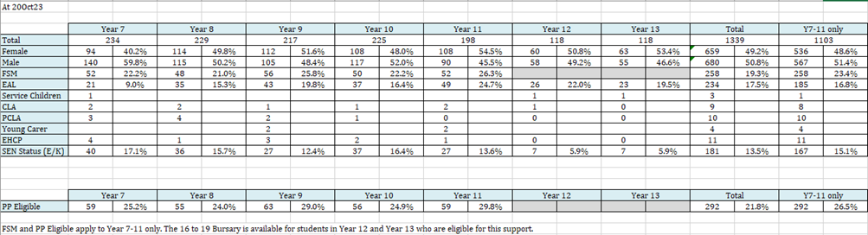
Staff data
 | Whole school | Middle Leadership | Senior Leadership
Male | 45 | 7 | 5
Female | 91 | 10 | 6

2. Legislation and guidance
This document meets the requirements under the following legislation:
- The Equality Act 2010, which introduced the public sector equality duty and protects people from discrimination
- The Equality Act 2010 (Specific Duties) Regulations 2011, which require schools to publish information to demonstrate how they are complying with the public sector equality duty and to publish equality objectives

This document is also based on Department for Education (DfE) guidance: The Equality Act 2010 and schools.

3. Roles and responsibilities
The governing board will:
- Ensure that the equality information and objectives as set out in this statement are published and communicated throughout the school, including to staff, pupils and parents (website), and that they are reviewed and updated at least once every four years.
- Equality information will be reviewed yearly on the website to ensure it is accurate and reflects the current school context.
- Delegate responsibility for monitoring the achievement of the objectives on a daily basis to the Headteacher.

The equality link governor will:
- Meet with the designated member of staff for equality and other relevant staff members every term to discuss any issues and how these are being addressed
- Ensure they’re familiar with all relevant legislation and the contents of this document
- Attend appropriate equality and diversity training
- Report back to the full governing board regarding any issues

The Headteacher will:
- Promote knowledge and understanding of the equality objectives amongst staff and pupils
- Monitor success in achieving the objectives and report back to governors

The designated member of staff for equality will: (Amy Burgum)
- Support the Principal in promoting knowledge and understanding of the equality objectives amongst staff and pupils
- Liaise with the equality link governor every term to raise and discuss any issues
- Support the Principal in identifying any staff training needs, and deliver training as necessary

All school staff are expected to have regard to this document and to work to achieve the objectives as set out in section 8.

4. Eliminating discrimination
The school is aware of its obligations under the Equality Act 2010 and complies with non-discrimination provisions.

Where relevant, our policies include reference to the importance of avoiding discrimination and other prohibited conduct.

Staff and governors are regularly reminded of their responsibilities under the Equality Act, for example during meetings. Where this has been discussed during a meeting it is recorded in the meeting minutes.

Staff will be required to read the most recent school Equality Policy, alongside Safeguarding, Child Protection and GDPR documents. They will sign a register to confirm they have done this.
The school has a designated member of staff for monitoring equality issues, and an equality link governor. They regularly liaise regarding any issues and make senior leaders and governors aware of these as appropriate.

The school fosters equality and aims to eliminate discrimination by taking every opportunity to promote the school values. This is done in lessons, form time and assemblies. Since September 2021, the school values have been an integral part of the school house system, with students being awarded for demonstrating values and houses competing every year for the five values cups. House competitions are open to all cohorts and are accessible irrespective of characteristic (disability, sexuality, age, need).

Our school values
Respect
Resilience
Integrity
Compassion
Ambition

5. Advancing equality of opportunity
As set out in the DfE guidance on the Equality Act, the school aims to advance equality of opportunity by:
- Removing or minimising disadvantages suffered by people which are connected to a particular characteristic (e.g. pupils with disabilities, or gay pupils who are being subjected to homophobic bullying)
- Taking steps to meet the particular needs of people who have a particular characteristic (e.g. enabling Muslim pupils to pray during Ramadan and enabling students of all abilities to access the curriculum and every area of the school building)
- Encouraging people who have a particular characteristic to participate fully in any activities (e.g. encouraging all pupils to be involved in the full range of school activities)
- Encouraging students of all ages to play an active role in school events, celebrations and organised workshops.
- Ensuring that all students in our school community are treated fairly and equally irrespective of gender, sexuality or race.

In fulfilling this aspect of the duty, the school will:
- Update and make reference to the school Equal Opportunity Policy
- Publish attainment data each academic year showing how pupils with different characteristics are performing (OBT)
- Analyse the above data to determine strengths and areas for improvement, implement actions in response and publish this information
- Make evidence available identifying improvements for specific groups (e.g. declines in incidents of homophobic or transphobic bullying) - e.g our participation in HBSC and My health, My School surveys.
- Monitor data about any issues associated with particular protected characteristics, identifying any issues which could affect our own pupils.

6. Fostering good relations.
The school aims to foster good relations between those who share a protected characteristic and those who do not share it by:
- Promoting tolerance, friendship and understanding of a range of religions and cultures through different aspects of our curriculum. This includes teaching in RE, citizenship and personal, social, health and economic (PSHE) education, but also activities in other curriculum areas.
- Ensuring assemblies take place every week (virtually when appropriate) which promote fostering of good relations and which deal with associated issues. This will also be linked to school values and the role they play in ensuring continued good relations.
- Working with our local community. This includes inviting leaders of local groups to speak at assemblies and PSHE days (when appropriate) It may also involve organising trips and activities based around the local community.
- Encouraging and implementing initiatives to deal with tensions between different groups of pupils within the school. For example, our school council has representatives from different year groups and is formed of pupils from a range of backgrounds. We also have a School Council who aim to encourage positive relationships within peer groups. All pupils are encouraged to participate in the full range of the school’s co-curricular activities (when appropriate to do so) and these are made accessible to all.
- We have developed links with people and groups who have specialist knowledge about particular characteristics, which helps inform and develop our approach
- We are aware of the diverse range of student groups and use this data to inform planning to meet these students’ needs. See table below:

Ethnicity
Pudsey Grammar School welcomes and celebrates having students from all cultures and ethnicities.

In year 7, 172 students identified as White British, 13 as White English.
The other three largest ethnic groups were Pakistani, Other, White British and Indian.

In year 8, 161 students identified as White British, 15 as White English.
The other three largest ethnic groups were Pakistani, White and Black Caribbean and other mixed background.

In year 9, 163 students identified as White British, 11 as Pakistani.
The other three largest ethnic groups were Indian, White and Black Caribbean and other mixed background.

In year 10, 174 students identified as White British, 10 as Pakistani.
The other three largest ethnic groups were Indian, White and Black African and White and Black Caribbean.

In year 11, 139 students identified as White British, 9 as Black African.
The other three largest ethnic groups were White Eastern European, Pakistani and Indian.

In our P16 cohort, 164 students identified as White British, 19 as Pakistani.
The other three largest ethnic groups were White English, Indian and Black African.

English as an additional language (EAL)
- SJC leads on EAL and drives initiatives as well as supporting students.
- Since 2018 there has been a continued growth in EAL students attending PGS.
- As of our current cohort, we have 234 on roll.
- We have 41 different languages spoken, other than English spoken in school.
- Aside from English, the three most commonly spoken languages are Urdu, Punjabi and Polish.
- EAL students are Identified on ClassCharts seating plans to support teaching and learning.
- SJC leads on support groups and sessions with students depending on proficiency scales.(A being new to English, E being fluent.)
- Students are supported to complete exams in their home language subject.SJC oversees a year round action plan, linked to assessment and intervention when required.

Correct as of October 2023.

 | Year 7 | Year 8 | Year 9 | Year 10 | Year 11 | Year 12 | Year 13 | Total
EAL | 21 (9%) | 35 (15.3%0 | 43 (19.8%) | 37 (16.4%) | 49 (24.7%) | 26 (22%) | 23 (19.5%) | 234 (17.5%)

Gender
In year 7: There are more males (59.8%), than females (40.2%).
In year 8: There is a more even distribution of males (50.2%) and females (49.8%).
In year 9: A similar picture to year 8, though more females (51.6%) than males (48.4%).
In year 10: A distribution of 48% females and 52% males.
In year 11: We currently have 54.5% females and 45.5% males.
P16: In year 12 percentages are closer with 50.8% females and 49.2% males, in year 13, this shows as 53.4% female and 46.6% male.

Overall in Pudsey Grammar School there are:
49.2% female students. 50.8% male students.

Disabilities
Students with additional needs including those who could be classed as disabled are identified at transition from primary school and are monitored closely by the SENCO, Director of Studies and Year Leaders. We have a designated SEND library area and access to a number of disabled toilets and lifts. The student support register and individual pupil profiles contain specific advice and guidance to staff about the needs of these students. We currently have one student in school in a wheelchair.

Sexual Orientation and Gender reassignment
The school does not collect information on the sexual orientation of students. Were it to be communicated to the school regarding a pupil, it would be recorded in the child’s file and confidentiality would be maintained. No data is collated by the school about gender reassignment.

Religion (Correct as of October 2023.)
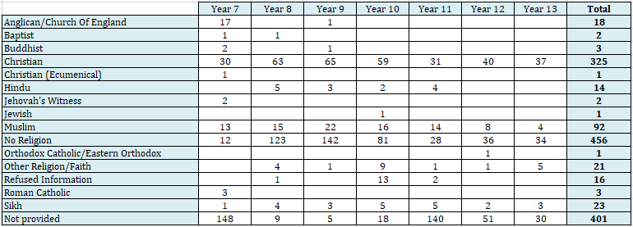

7. Equality considerations in decision-making

The school ensures it has due regard to equality considerations whenever significant decisions are made.

The school always considers the impact of significant decisions on particular groups. For example, when a school activity or sale of resources is being planned, the school considers whether this:
- Impacts on any religious holidays
- Is accessible to pupils with disabilities
- Has equivalent access for boys and girls
- Is accessible to all pupils, regardless of cost

The school keeps a record to show we have actively considered our equality duties and asked ourselves relevant questions. This is recorded at the same time as the risk assessment when planning school trips (Evolve system) and activities. The record is completed by the member of staff organising the activity and is stored electronically with the completed risk assessment.

The school is aware of the different groups of students who may be affected by decisions taken by the school and we use this information to inform planning and implementation of any school activity or when resources are made available for purchase. Please see table below:

Free School Meals
274 students (20.6%) are known to be eligible for free school meals. The school has a fund to provide financial support for families for items such as uniform, trips and equipment.

Pupil Premium
275 students (25.1% of Year 7-11 students) are known to be eligible for Pupil Premium (at 01 Apr23)
Attendance
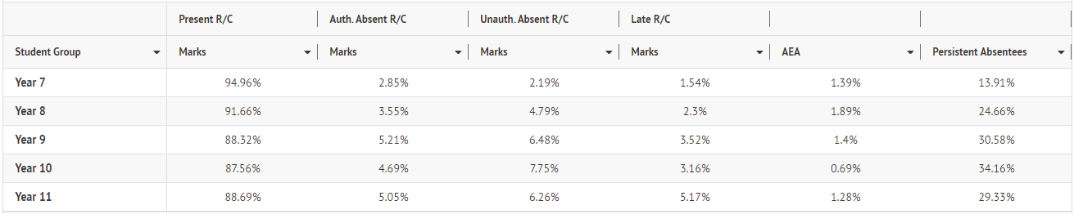
There is a team of attendance officers who monitor this daily. Additionally, in Post-16, attendance is a focus – weekly attendance reports.

For non-attenders/students off school; work is available to them on google classrooms, through our class charts systems and in accessing Oak National Academy. This enables them to continue with their learning.

SEN
CLA/Previously looked-after

8. Equality objectives
In accordance with the Equality Act (2010), we adhere to a series of Equality Objectives to build upon our achievements year on year. Our current Equality Objectives (2023-2024) include the following key objectives:
- To continue to embed and improve our PSHE offer and the curriculum-based work on discrimination linked to race, faith, sex, gender identity, sexual orientation, disability and socio-economic disadvantage.
- To build and nurture our support for LGBT+ students and serve as a school setting outlining best practice.
- To utilise the school council in our work to increase student and community engagement in our work related to equality, diversity, social justice and local charity support.
- To continue to narrow the gap in achievement between students from different backgrounds and contexts.

9. Monitoring arrangements
In consultation with the designated member of staff for equality, Amy Burgum will update the equality information we publish, [described in sections 4-7 above] every year.
This document will be reviewed by the governing body at least annually.
This document will be approved by the governing body and the Headteacher.

10. Links with other policies
This document links to the following policies:
- Accessibility plans
- Risk assessments
- Equality Policy
- Equal Opportunities Policy

