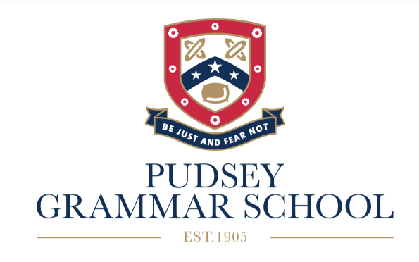

**Key Stage 4**

**Guided Choices 2025**

Name ……………………………………………….

Form ……………………………………………….

Welcome to the guided choices process in Year 9. This is an exciting time for you, as you now have the opportunity to choose some of the courses you would like to take in Years 10 and 11.

This guidance will help you and your parents/carers understand the process and will give you some suggestions about how to choose the courses. There is also a lot of support at hand and you can discuss your choices with your subject teachers, form tutor, Director of Studies and parents/carers.

All students will be guided with their choices. We want the courses chosen by students to provide them with the best possible chance of success, as well as ensuring that their curriculum is broad, balanced and enjoyable.

**Core Subjects**

All students will take the following subjects in Year 10 and 11:

English Language and Literature GCSE,

Mathematics GCSE,

Combined Science (2 x GCSE).

Some students will take Triple Science.

Students will also take the non-examined courses of PE, Core RE and

PSHE (Personal, Social and Health Education).

**Important Dates in the Guided Choices Process**

Guided Choices Assembly- Wednesday 19th March

Guided Choices pamphlet given to students – Thursday 20th March

Subject Fair -Thursday 20th March 5-7pm (presentations at 5pm and 6pm)

Guided Choice forms open - Friday 21st March

Deadline for completed forms – Thursday 27th March

Meetings with some students to discuss choices – After Easter holidays

Letters to go to parents/carers with course selection -End of May

**Guided Choices**

In addition to the Core Subjects, you must choose History or Geography GCSE. You can pick History and Geography. We will be encouraging as many students as possible to pick a Modern Foreign Language which are French or Spanish. Students must then pick 3 more courses. This gives 4 courses in total. The courses must fit into the Guided Choices Blocks, with one course from each of the 4 blocks. You must also pick 2 reserve courses from any of the blocks just in case we are unable to offer your preferred courses.

**How to choose**

You should select courses that;

* you are interested in,
* you have the relevant skills in, or are keen to develop those skills,
* you can be successful in,
* may be relevant to any future career aspirations.

**Combinations of subjects**

You **cannot** choose the following subjects together;

* Enterprise (BTEC) and Business GCSE,
* ICT (BTEC) and Computing GCSE,
* Performing Arts (BTEC) and Drama GCSE,
* Construction (BTEC) and Product Design GCSE.

**Guided Choices Blocks**

The courses must fit into the Guided Choices Blocks below, with one course from each of the 4 blocks. You must also pick 2 reserve courses from any of the blocks just in case we are unable to offer your 4 preferred courses. *These are vocational courses.

| **Block 1** | **Block 2** | **Block 3** | **Block 4** |
| --- | --- | --- | --- |
| Art    GCSE | Art  GCSE | Business Studies    GCSE | *Child Development  BTEC |
| *Enterprise  BTEC | Business Studies  GCSE | Computing    GCSE | *Enterprise  BTEC |
| Geography  GCSE | *Construction    Technical Award | Drama  GCSE | French    GCSE |
| History  GCSE | Geography  GCSE | Geography  GCSE | Geography    GCSE |
| *Hospitality & Catering  BTEC | *Health & Social Care    BTEC | History  GCSE | History    GCSE |
| *Performing Arts  BTEC | History    GCSE | *Hospitality & Catering  BTEC | *Media    Cambridge National |
| PE    GCSE | *ICT  BTEC | *Media  Cambridge National | Photography  GCSE |
| RE  GCSE | *Music  BTEC | Photography  GCSE | Product Design    GCSE |
| Spanish  GCSE | RE  GCSE | PE    GCSE | PE    GCSE |

**Types of courses**

You should also consider the type of course as well;

* Many GCSEs (e.g. Maths, History) are 100% examined at the end of Year 11.
* Practical GCSEs (e.g. Art, Drama, Product Design) and vocational courses (e.g. Enterprise, Media) have a controlled assessment/ coursework element (60%) as well as an end of course examination (40%).
* Vocational courses have internally assessed units which are set by the exam boards. You must have excellent attendance to prepare and complete these units in the given time.

**What will happen if a course is oversubscribed or undersubscribed?**

There is only one class for each of the courses in the blocks. The maximum size of a class depends on the type of course. For example, History GCSE classes can have a maximum of 32 students, whereas practical subjects like Product Design GCSE are smaller with a maximum number of 20 students. If a course is oversubscribed we will use students’ KS3 assessments and ATLs to help decide if they are suitable to take the course. A course may not run if the numbers are not viable.

**How to find out more about the different courses**

At the Subject Fair each of the subject areas will be represented and will have information about the courses they run. You will be able to find out more about the different courses by talking to the teachers on that evening. There is also a great deal of information on the school website about each course including the content of the course, how it is assessed and examples of students’ work;

[www.pudseygrammar.co.uk](http://www.pudseygrammar.co.uk)

then click on the tabs; Year 6-11/Year 9/Guided Choices 2025

Or use the QR code below;