Our ref: MME/HFT
Date: 13th November 2020

FAO: Parents or carers of children that have had direct contact with a confirmed positive case.

Dear Parent/Carer,

We have been advised by Public Health England that there has been a confirmed case of COVID-19 within the school.

We have followed the national guidance and have identified that your child has been in close contact with the affected child. In line with the national guidance we recommend that your child now stay at home and self-isolate. The date that they should return to school is in the accompanying text message.

We are asking you to do this to reduce the further spread of COVID 19 to others in the community.

If your child is well at the end of self-isolation period, then they can return to school.

Other members of your household can continue normal activities provided your child does not develop symptoms within the self-isolation period.

Please see the link to: Guidance for contacts of people with confirmed coronavirus (COVID-19) infection who do not live with the person

https://www.gov.uk/government/publications/guidance-for-contacts-of-people-with-possible-or-confirmed-coronavirus-covid-19-infection-who-do-not-live-with-the-person

What to do if your child develops symptoms of COVID 19
If your child develops symptoms of COVID-19, they should remain at home for at least 10 days from the date when their symptoms appeared. Anyone with symptoms will be eligible for testing and this can be arranged via https://www.nhs.uk/ask-for-a-coronavirus-test or by calling 119 .

All other household members who remain well must stay at home and not leave the house for 14 days. This includes anyone in your ‘Support Bubble’.

The 14-day period starts from the day when the first person in the house became ill.

Household members should not go to work, school or public areas and exercise should be taken within the home. If you require help with buying groceries, other shopping or picking up medication, or walking a dog, you should ask friends or family. Alternatively, you can order your shopping online and medication by phone or online.

Household members staying at home for 14 days will greatly reduce the overall amount of infection the household could pass on to others in the community

If you are able can, move any vulnerable individuals (such as the elderly and those with underlying health conditions) out of your home, to stay with friends or family for the duration of the home isolation period

Please see the link to the PHE ‘Stay at Home’ Guidance:
https://www.gov.uk/government/publications/covid-19-stay-at-home-guidance/stay-at-home-guidance-for-households-with-possible-coronavirus-covid-19-infection

Symptoms of COVID 19
The most common symptoms of coronavirus (COVID-19) are recent onset of:
- new continuous cough and/or
- high temperature and/or
- a loss of, or change in, normal sense of taste or smell (anosmia)

For most people, coronavirus (COVID-19) will be a mild illness.

If your child does develop symptoms, you can seek advice from NHS 111 at https://www.nhs.uk/conditions/coronavirus-covid-19/check-if-you-have-coronavirus-symptoms/ or by phoning 111.

How to stop COVID-19 spreading
There are things you can do to help reduce the risk of you and anyone you live with getting ill with COVID-19

Do
- wash your hands with soap and water often – do this for at least 20 seconds
- use hand sanitiser gel if soap and water are not available
- wash your hands as soon as you get home
- cover your mouth and nose with a tissue or your sleeve (not your hands) when you cough or sneeze
- put used tissues in the bin immediately and wash your hands afterwards

Further Information
Further information is available at
https://www.nhs.uk/conditions/coronavirus-covid-19/
Yours sincerely,

Mr M McKelvie
Principal

Access to Google Classroom for students who are self – isolating (Yr 7 – 9)
- Students should sign in to their school account and access Google Classroom through the tiles on the home screen.

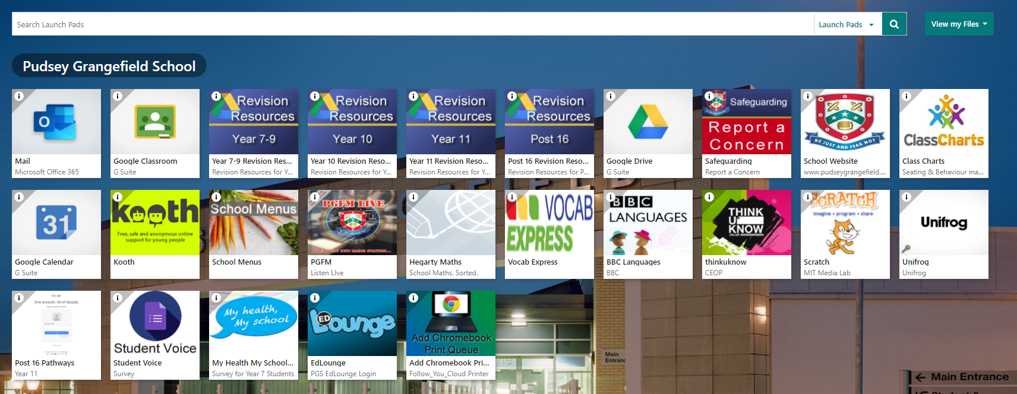

- Go to the relevant year group folder for self – isolating students (example shown is Year 7)

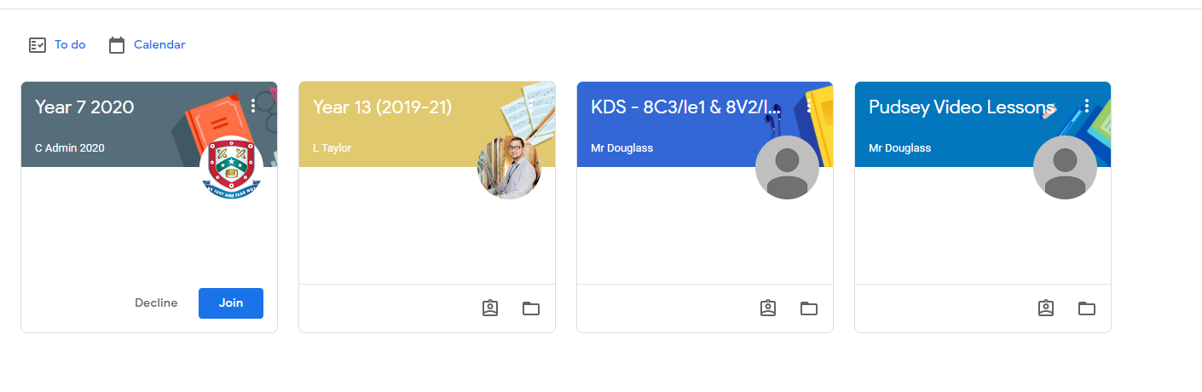
- Open the classroom, click on ‘Classwork’ tab and scroll down to see the full range of subjects. Find the most up to date work that has been set from the list. There will be enough work from each subject to cover a two - week absence.
