

YEAR 11 SUMMER HOLIDAY TASK - A LEVEL PSYCHOLOGY

Psychology in Action – THE RESEARCH

~ The purpose of this research is to determine whether people will go along with the judgements of others in a situation where they are unsure how to respond.
~ In this investigation every one who helps has to be treated identically apart from one difference.
~ You need to choose the situation of uncertainty to place people in. These are the sorts of options to choose from:
Guessing how many people in Leeds were diagnosed with Alzheimer’s disease in 2010
Guessing how many people in Leeds were diagnosed with a sleep disorder in 2012
Guessing how many vowels are present on a sheet of text.
Guessing how many burglaries occurred in January 2014 in Leeds
~ Everyone who assists with the investigation will be placed in the same situation of uncertainty.
~ The one difference is whether they receive forms to put their answer on which include high fake guesses or low ones
Example guess form - condition 1
Please estimate how many secondary school students in Leeds were excluded for a short period of time (up to a week) in 2013.
Place your estimation in the next empty space

159
147
153
155
150
152

Example guess form – condition 2
Please estimate how many secondary school students in Leeds were excluded for a short period of time (up to a week) in 2013.
Place your estimation in the next empty space.
59
47
53
55
50
52

PLEASE NOTE: the guesses in condition 2 are faked 100 lower than those in condition 1.The difference needs to be constant, the size of the difference depends on the situation of uncertainty. For example, the number of burglaries in Leeds in January 2014 might be faked around 500 in condition 1 and around 200 in condition 2. Eg, 529 versus 229, 578 versus 278. The fake guesses would be hand written to be realistic.
Procedure
~ 10 people will receive a form with the high fake judgements, (You need to make 10 forms)
~ 10 people will receive a form with the low fake judgements. (You need to fake 10 forms) This is the only difference, the size of the fake guesses. Everything else remains constant.
~ 10 people will be needed to fill in the low fake guess form = Condition 1
~ 10 people will be needed to fill in the high fake guess form = Condition 2
~ The people who take part in the research will be people you know who are 16 or over. In total you will need to recruit 20 people.
~ The materials you need are:
- 10 guess forms filled in with the same 6 high fake judgements.
- 10 guess forms filled in with the same 6 low fake judgements.
- The question which creates the situation of uncertainty appears at the top of each sheet as shown above.
- a script (you will read this out to each person to ensure each person receives exactly the same information)
The script:
~ Could you spare a moment to help me with something for school? It will only take a moment to help, and I will tell you what you have helped with as soon as you have taken part.
~ Thank you for agreeing to assist. Please read this question and fill in your answer to the question in the next empty space. You will see that several people have helped me already.
~ I've got a pen here. Here’s the sheet, can you read the question and fill in the next empty space please.
~ Thank you.
The Debrief:
I can now tell you that you have just helped with a psychology investigation. The research is designed to find out whether people will go along with the views of others when they are unsure what the correct answer is. The estimations on the form were false ones. They were made up to be similar, to see if you went along with them. Whatever you put down is fine. Can I check that it is okay to use your guess in my research please? Thank you

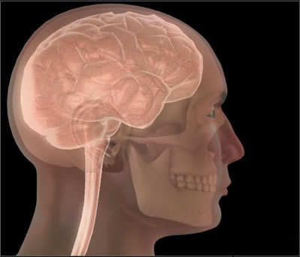


THE WRITE UP TOTAL MARKS = 25

You need to write up a report which follows the format below.
1. Give your report a title (1 mark)
2. State the aim of the research (2 marks)
3. Identify the 2 conditions (1 mark)
4. Describe the procedure you followed to collect the data. This should include:
- a description of the people who assisted: total number, age and sex breakdown(2 marks)
- a description of the materials used. All completed forms should be included (2 marks)
- the script + debrief (2 marks)
5. Present the findings:
a. Draw a table which includes the 10 guesses for condition 1 and the 10 guesses for condition 2. Label this Raw Data (3 marks)
b. Draw a table which includes the mean guess for condition 1 and the mean guess for condition 2 and the range for condition 1 and condition 2. Give the table a title (5 marks)
c. Use this table to provide a written summary of the findings from your research. Did people who saw high guesses arrive at higher judgements than people who saw low guesses? Did everyone go along with the group or were differences evident? (3 marks)
6. Arrive at a conclusion. Do your findings support the claim that when unsure people look to others to decide what to do? In other words are you concluding that conformity occurred as a result of social influence or are you concluding that the people in your research were not influenced by the judgements of others? (3 marks)
~ Finally... Remember to include your name + date! (1 mark)
Your checklist for the write up – these headings should appear
Title
Aim
The 2 conditions
Procedure
Findings
Conclusion



