Introduction Booklet for A-Level Chemistry Students

Course starts: September 2019

Name________________

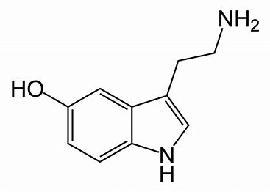

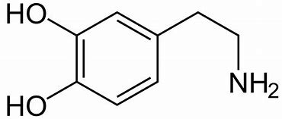

Task 1

Naming and drawing compounds – counting to 10 in chemistry

- Give the name of a 2 carbon alkane ____________________________________

- How many carbon atoms does butanol contain? ______________________________

- Give the name of a 10 carbon alkane. _____________________________________

- Draw the structure of propane.

- Name the molecule below. ____________________________________________
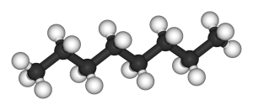

Task 2

Rounding, significant figures and standard form

- Put the following numbers into standard form;
826137920 0.000052848

__________________________________________________________________
- Convert the following numbers from standard form.
6.82x10⁻⁴ 4.29x10⁵

__________________________________________________________________
- Express the following numbers to 3 significant figures
32574893 0.63473965

__________________________________________________________________
- Round these numbers up or down where appropriate to give 2 decimal places.
93.994344 374.28773

__________________________________________________________________
- Express these numbers to 4 significant figures
56783 0.00758493

__________________________________________________________________

Task 3

- Write an equation for the production of ammonia from nitrogen and hydrogen.

- If 1000kg of nitrogen and 500kg of hydrogen were reacted, what would be the maximum theoretical yield of ammonia?

Calculating percentage yield

For the questions below find the theoretical mass and from the information given calculate the percentage yield. Use this balanced equation for your answers.

C₂H₆ + 3¹/₂O₂ 2CO₂ + 3H₂O
- What mass of carbon dioxide could be produced from 30g of ethane? (3)

- What would be the percentage yield if this experiment were carried out and only 62g of CO₂ were produced? (2)

Task 4
Rearranging formulae

- Rearrange the following formula to give ‘mass’ moles = mass
Mr

- Rearrange the following formula to give ‘volume’ moles = concentration x volume

- Rearrange the following formula to give ‘volume of gas’ moles of gas = volume of gas x 24

- Rearrange the following formula to give ‘Mr’ moles = mass
Mr

Task 5 Converting between units

- Convert the following into kg:

1g __

100g ___

0.1g___

1 x 10⁶ mg ___

- Convert the following into J:

- 1 MJ___

- 25kJ___

- 0.56 kJ___

- 2.5 x 10⁻² MJ___

